**Assignment 3 (WQUPC)**

**Step 1：**

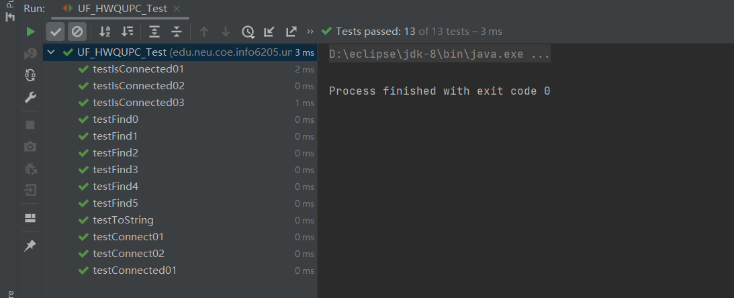

**Step 2:**

**Both count() and main() are created in UF_HWQUPC.java.**

Set n = 100;

Run count() for 100 times, then we can get the average number of pairs.

The result is:

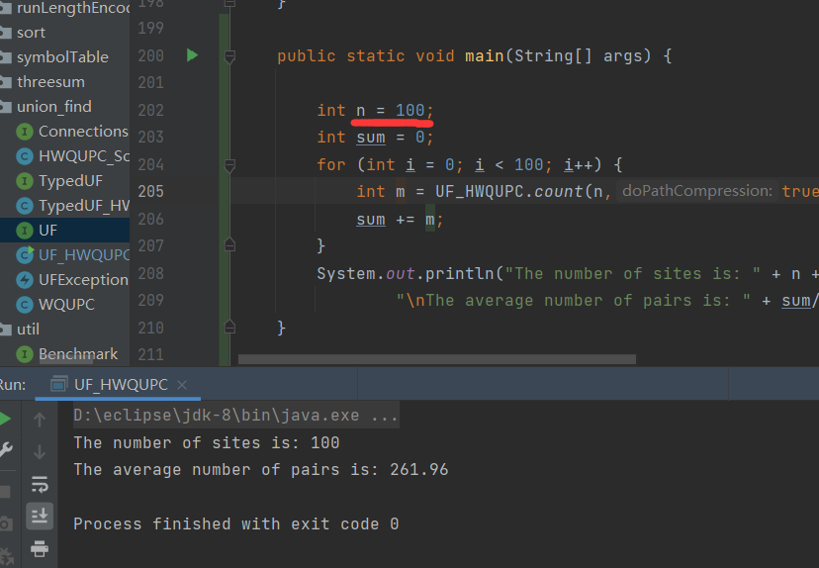

**When the number of sites is 100, the average number of pairs is 261.96.**

**Step 3:**

Set n = 100, 80, 60, 40, 20, 10.

The results are as follows:

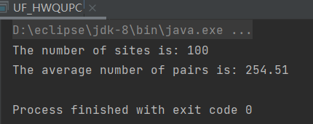

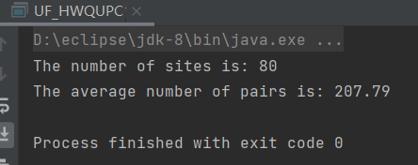

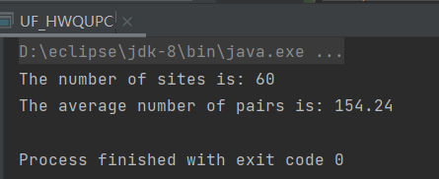

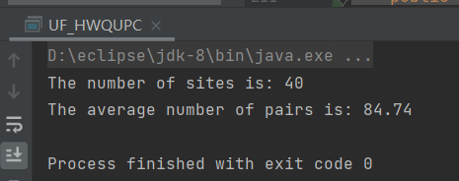

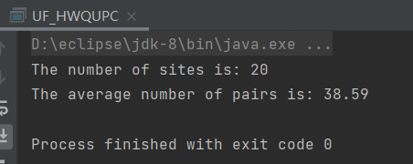

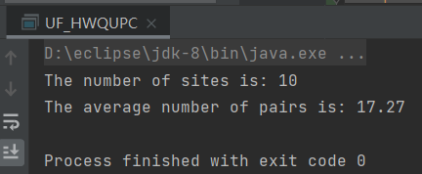

|  |  |  |  |  |  |  |
| --- | --- | --- | --- | --- | --- | --- |
| **n** | 100 | 80 | 60 | 40 | 20 | 10 |
| **pairs** | 254.51 | 207.79 | 154.24 | 84.74 | 38.59 | 17.27 |

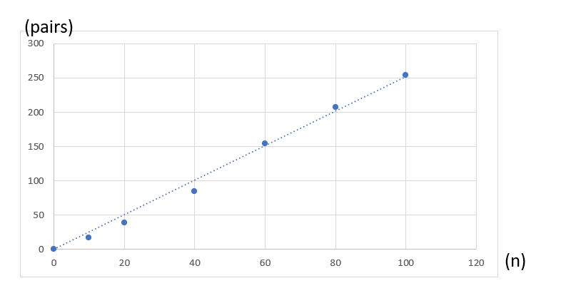

The relationship between **n** and **pairs** is **linear**.

**pairs = k * n.**